**Name: _________________________________**



**Task 2:**

SOURCE ANALYSIS, FORTNIGHTLY TASK THREE  **Weighting 2% (9 Marks)**

**Question 1**

1. Explain the message of **Source 1**.

***(3 marks)***

1. Identify how and discuss why **Sources 1** and **2** are contestable.

***(6 marks)***

***(Hint:*** *When discussing contestability make sure that you explain whether each source provides a certain interpretation of events for which other interpretations exist or whether the sources can be disputed)*

**Source 1:**

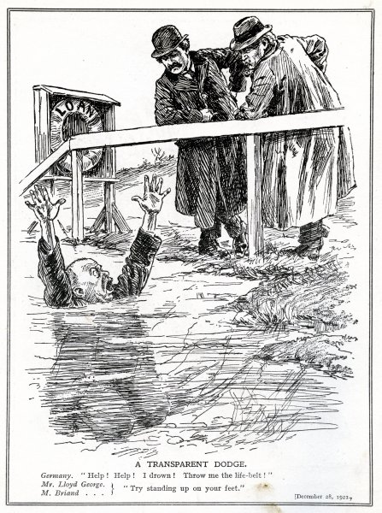

The image above is a British cartoon published in 1921. A “Transparent Dodge” means an obvious trick.

**Source 2:**

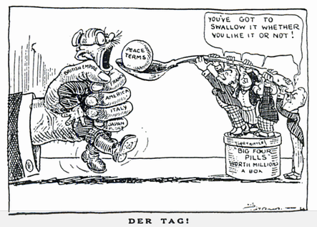

A British Cartoon titled “Der Tag” that was published in the Daily express in May 1919.